* **CSS:**
* CSS (**Cascading Styling Sheet)**is the language that defines the presentation of a document written in a markup language like HTML. CSS is the language that transforms a basic HTML structure into a user-friendly and visually beautiful webpage.
* It can change the font, color, size, and spacing of content, split it into multiple columns, or add animations and other features.
* **CSS Syntax**

CSS comprises style rules that are interpreted by the browser and then applied to the corresponding elements in your document. A style rule set consists of a selector and declaration block.

* **Selector:** A selector in CSS is used to target and select specific HTML elements to apply styles.
* **Declaration:**A declaration in CSS is a combination of a property and its corresponding value.

p {

**color**: blue;

**text-align**: center;

}

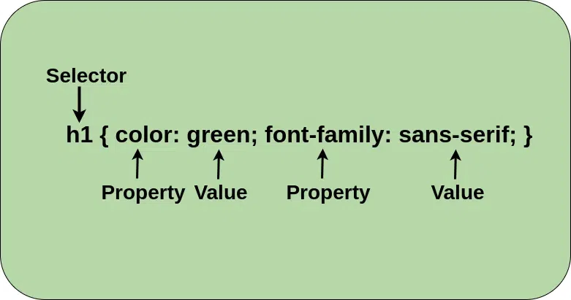

### CSS has 3 ways to style your HTML:

* [**Inline**](https://www.geeksforgeeks.org/inline-css/): Add styles directly to HTML elements (limited use).

<h1 style="color:blue;">A Blue Heading</h1>

* [**Internal**](https://www.geeksforgeeks.org/internal-css/): Put styles inside the HTML file in a **<style>** tag in the head tag.

<!DOCTYPE html>  
<html>  
<head>  
<style>  
body

{background-color: powderblue;

}

h1

 {color: blue;

}

p

{color: red;

}

</style>  
</head>  
<body>  
  
<h1>This is a heading</h1>  
<p>This is a paragraph.</p>  
  
</body>  
</html>

* [**External**](https://www.geeksforgeeks.org/external-css/): Create a separate CSS file (.css) and link it to your HTML.
* <!DOCTYPE html>  
  <html>  
  <head>  
    <link rel="stylesheet" href="styles.css">  
  </head>  
  <body>

Comments in css

* /* content */
* **Visualization of CSS Ruleset :**
* 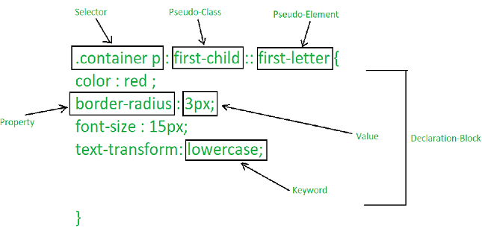

# CSS Colors

Color property refers to the foreground colour of the element.

**Built-In Color:**These are a set of predefined colors which are used by their names. For example: red, blue, green etc.

**RGB Format:** The RGB (Red, Green, Blue) format is used to define the color of an HTML element by specifying the R, G, and B values range between 0 to 255.

color: rgb(0, 153, 0);

* **RGBA Format:**The RGBA format is similar to the RGB, but it includes an Alpha component that specifies the transparency of elements.

color: rgba(204, 113, 153, 0.7);

* **Hexadecimal Notation:**The hexadecimal notation begins with a # symbol followed by 6 characters each ranging from 0 to F.

color: #ff5e62;

* **HSL:** HSL stands for Hue, Saturation, and Lightness respectively. This format uses the cylindrical coordinate system.

color: hsl(205, 75%, 50%);

* **HSLA:**The HSLA color property is similar to the HSL property, but it includes an Alpha component that specifies the transparency of elements.

color: hsla(120, 50%, 70%, 0.8);

# CSS Background

* **CSS background** sets the background of elements. It is used to define the background effects for elements in single line. There are lots of properties to design the background.

## ****CSS Background Property****

| **Background Property** | **Description** |
| --- | --- |
| [CSS Background-color Property](https://www.geeksforgeeks.org/css-background-color-property/#:~:text=The%20background%2Dcolor%20property%20in,to%20read%20for%20the%20user.) | The background-color property in CSS is used to specify the background color of an element. |
| [CSS Background-image Property](https://www.geeksforgeeks.org/css-background-image-property/) | The background-image property is used to set one or more background images to an element. |
| [CSS Background-repeat Property](https://www.geeksforgeeks.org/css-background-repeat-property/#:~:text=The%20background%2Drepeat%20property%20in,will%20be%20repeated%20or%20not.&text=The%20last%20image%20will%20be,fit%20in%20the%20browser%20window.) | The background-repeat property in CSS is used to repeat the background image both horizontally and vertically. |
| [CSS Background-attachment Property](https://www.geeksforgeeks.org/css-background-attachment-property/#:~:text=The%20property%20background%2Dattachment%20property,applied%20to%20all%20HTML%20elements.) | The background-attachment property in CSS is used to specify the kind of attachment of the background image with respect to its container.  background-attachment: scroll|fixed|local|initial|inherit; |
| [CSS Background-position Property](https://www.geeksforgeeks.org/css-background-position-property/) | In CSS body-position property is mainly used to set an image at a certain position.  background-position: *value*;  left top left center left bottom right top right center right bottom center top center center center bottom |
| [CSS Background-origin Property](https://www.geeksforgeeks.org/css-background-origin-property/) | The background-origin is a property defined in CSS which helps in adjusting the background image of the webpage. |
| [CSS Background-clip Property](https://www.geeksforgeeks.org/css-background-clip-property/) | The background-clip property in CSS is used to define how to extend the background (color or image) within an element. |

# CSS Text Formatting

The CSS **text formatting** properties are used to format text, style the text, and perform different types of manipulations like word spacing, alignment, justification, and text transformation.

1. [Text Color](https://www.geeksforgeeks.org/css-colors/): This property is used to set the color of the text and the color can be set by using a color name like “red”, hex value “#ff0000”, or by its RGB value “rgb(255,0,0)”;
2. [text-align](https://www.geeksforgeeks.org/css-text-align-last-property/): This property in CSS is used to specify the horizontal alignment of text in an element inside a block element or table-cell box.

Text alignment is done according to the parent alignment.

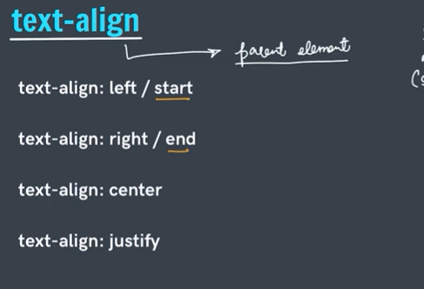

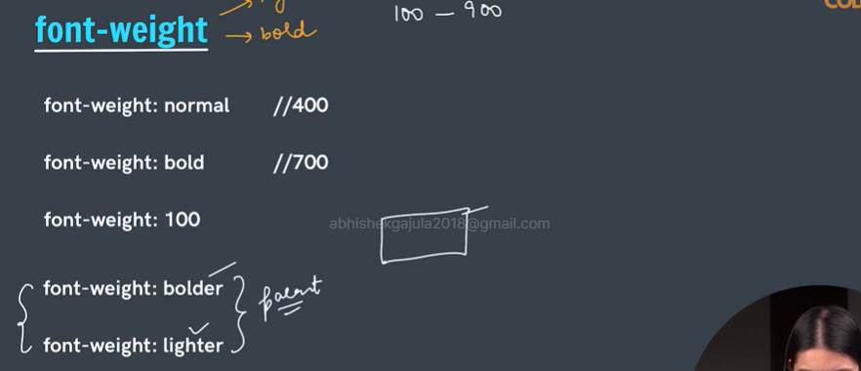

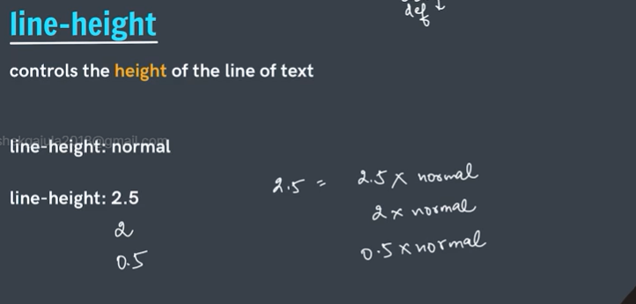

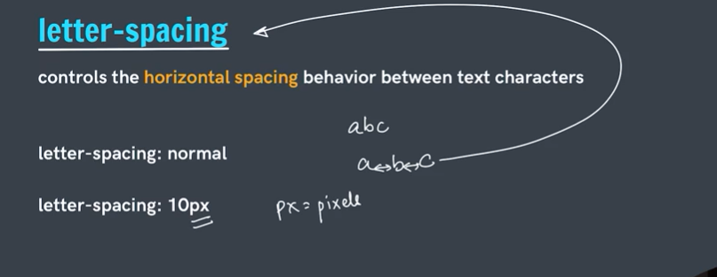

1. [text-align-last](https://www.geeksforgeeks.org/css-text-align-last-property/): It is used to set the last line of the paragraph just before the line break. It sets the alignment of all the last lines occurring in the element in which the text-align-last property is applied.
2. [text-decoration](https://www.geeksforgeeks.org/css-text-decoration-property/): text-decoration property is used to “decorate ” the content of the text.

text-decoration: line style color | initial | inherit;

/* for example

text-decoration: underline dashed green;

*/

### **CSS text-decoration shorthand property for:**

* [text-decoration-line](https://www.geeksforgeeks.org/css-text-decoration-line-property/) : use to sets the type of line decoration for our text.
* text-decoration-line: none| underline| overline| line-through| initial| inherit;
* [text-decoration-color](https://www.geeksforgeeks.org/css-text-decoration-color-property/) : use to sets the color for the line decoration.
* text-decoration-color: color|initial|inherit;
* [text-decoration-style](https://www.geeksforgeeks.org/css-text-decoration-style-property/) : use to sets the style of the line specified by text-decoration-line.
* text-decoration-style: solid|double|dotted|dashed|wavy|initial|
* [text-decoration-thickness](https://www.geeksforgeeks.org/css-text-decoration-thickness-property/) : use to sets the thickness of the line used in decoration.

1. [text-decoration-color](https://www.geeksforgeeks.org/css-text-decoration-color-property/): It is used to set the color of the decorations (overlines, underlines, and line-throughs) over the text.
2. [text-decoration-line](https://www.geeksforgeeks.org/css-text-decoration-line-property/): It is used to set the various kinds of text decorations. this may include many values such as underline, overline, line-through, etc.
3. [text-decoration-style](https://www.geeksforgeeks.org/css-text-decoration-style-property/): This property is used to set the text-decoration of the element. It is the combination of the text-decoration-line and text-decoration-color properties.
4. [text-indent](https://www.geeksforgeeks.org/css-text-indent-property/): It is used to indent the first line of the paragraph and the size can be in px, cm, pt.
5. [text-justify](https://www.geeksforgeeks.org/css-text-justify-property/): This property is used to set the text-align to justify. It spreads the words into complete lines.
6. [text-overflow](https://www.geeksforgeeks.org/css-text-overflow-property/): This property of text formatting specify that some text has overflown and is hidden from the view.
7. [text-transform](https://www.geeksforgeeks.org/css-text-transform-property/): It is used to control the capitalization of the text.
8. [text-shadow](https://www.geeksforgeeks.org/css-text-shadow-property/): it is used to add shadow to the text.
9. [letter-spacing](https://www.geeksforgeeks.org/css-letter-spacing-property/): This property is used to specify the space between the characters of the text.
10. [line-height](https://www.geeksforgeeks.org/css-line-height-property/): It is used to set the space between the lines.
11. [direction](https://www.geeksforgeeks.org/css-direction-property/): This property is used to set the direction of the text.
12. [word-spacing](https://www.geeksforgeeks.org/css-word-spacing-property/): It is used to specify the space between the words of the line.

# **CSS Units**

Absolute Lengths

The absolute length units are fixed and a length expressed in any of these will appear as exactly that size.

Absolute length units are not recommended for use on screen, because screen sizes vary so much. However, they can be used if the output medium is known, such as for print layout.

|  |  |
| --- | --- |
| **Unit** | **Description** |
| cm | centimeters[Try it](https://www.w3schools.com/cssref/tryit.php?filename=trycss_unit_cm) |
| mm | millimeters[Try it](https://www.w3schools.com/cssref/tryit.php?filename=trycss_unit_mm) |
| in | inches (1in = 96px = 2.54cm)[Try it](https://www.w3schools.com/cssref/tryit.php?filename=trycss_unit_in) |
| px * | pixels (1px = 1/96th of 1in)[Try it](https://www.w3schools.com/cssref/tryit.php?filename=trycss_unit_px) |
| pt | points (1pt = 1/72 of 1in)[Try it](https://www.w3schools.com/cssref/tryit.php?filename=trycss_unit_pt) |
| pc | picas (1pc = 12 pt) |

Relative Lengths

Relative length units specify a length relative to another length property. Relative length units scale better between different rendering medium.

|  |  |  |
| --- | --- | --- |
| **Unit** | **Description** |  |
| em | Relative to the font-size of the element (2em means 2 times the size of the current font) | [Try it](https://www.w3schools.com/cssref/tryit.php?filename=trycss_unit_em) |
| ex | Relative to the x-height of the current font (rarely used) | [Try it](https://www.w3schools.com/cssref/tryit.php?filename=trycss_unit_ex) |
| ch | Relative to the width of the "0" (zero) | [Try it](https://www.w3schools.com/cssref/tryit.php?filename=trycss_unit_ch) |
| rem | Relative to font-size of the root element | [Try it](https://www.w3schools.com/cssref/tryit.php?filename=trycss_unit_rem) |
| vw | Relative to 1% of the width of the viewport* | [Try it](https://www.w3schools.com/cssref/tryit.php?filename=trycss_unit_vw) |
| vh | Relative to 1% of the height of the viewport* | [Try it](https://www.w3schools.com/cssref/tryit.php?filename=trycss_unit_vh) |
| vmin | Relative to 1% of viewport's* smaller dimension | [Try it](https://www.w3schools.com/cssref/tryit.php?filename=trycss_unit_vmin) |
| vmax | Relative to 1% of viewport's* larger dimension | [Try it](https://www.w3schools.com/cssref/tryit.php?filename=trycss_unit_vmax) |
| % | Relative to the parent element |  |

# Selectors in css:

1. **Types of CSS Selectors**
2. CSS selectors come in various types, each with its unique way of selecting HTML elements. Let’s explore them:

| **CSS Selectors** | **Description** |
| --- | --- |
| **Simple Selectors** | It is used to select the HTML elements based on their element name, id, attributes, etc |
| [**Universal Selector**](https://www.geeksforgeeks.org/css-selector/) | Selects all elements on the page.  * {  color: white;  background-color: black; } |
| [**Attribute Selector**](https://www.geeksforgeeks.org/css-attribute-selector/) | Targets elements based on their attribute values.  [href] {  background-color: lightgreen;  color: black;  font-family: monospace;  font-size: 1rem; } |
| [**Pseudo-Class Selector**](https://www.geeksforgeeks.org/css-pseudo-classes/) | Selects elements based on their state or position, such as :hover for hover effects.  h1:hover{  background-color: aqua; }  **Note:** We use a single colon(:) in the case of a [Pseudo-Class Selector](https://www.geeksforgeeks.org/css-pseudo-classes/). |
| [**Combinator Selectors**](https://www.geeksforgeeks.org/css-combinators/) | Combine selectors to specify relationships between elements, such as descendants ( ) or child (>). |
| [**Pseudo-Element Selector**](https://www.geeksforgeeks.org/css-pseudo-elements/) | Selects specific parts of an element, such as ::before or ::after.  **Note:**We use a double colon(::) in the case of a[Pseudo-Element Selector](https://www.geeksforgeeks.org/css-pseudo-elements/).  Selector:Pseudo-Element{  Property:Value;  } |

| **Simple Selector** | **Description** |
| --- | --- |
| [**Element Selector**](https://www.geeksforgeeks.org/css-element-element-selector/) | Selects HTML elements based on their tag names.  h1 {  color: red;  font-size: 3rem; } |
| [**Id Selector**](https://www.geeksforgeeks.org/css-id-selector/) | Targets an HTML element with a specific id attribute.  Id can be given to multiple elements but not recommended.  #div-container{  color: blue;  background-color: gray; } |
| [**Class Selector**](https://www.geeksforgeeks.org/css-class-selector/) | Selects elements with a particular class attribute.  .paragraph-class {  color:white;  font-family: monospace;  background-color: purple; }  Specially used in grouping the elements |

## ****Group Selector****

The **Group selector** is used to style all comma-separated elements with the same style.

#div-container, .paragraph-class, h1{  
 color: white;  
 background-color: purple;  
 font-family: monospace;   
}

# CSS Combinators

# CSS combinators are explaining the relationship between two selectors.

There are four types of combinators available in CSS which are discussed below:

* General Sibling selector (~)
* Adjacent Sibling selector (+)
* Child selector (>)
* Descendant selector (space)

<!DOCTYPE html>

<html>

<head>

<title>Combinator Property</title>

<style>

div ~ p{

color: #009900;

font-size:32px;

font-weight:bold;

margin:0px;

text-align:center;

}

div {

text-align:center;

}

</style>

</head>

<body>

<div>General sibling selector property</div>

<p>GeeksforGeeks</p>

<div>

<div>child div content</div>

<p>G4G</p>

</div>

<p>Geeks</p>

<p>Hello</p>

</body>

</html>

**General Sibling selector:** The general sibling selector is used to select the element that follows the first selector element and also shares the same parent as the first selector element. This can be used to select a group of elements that share the same parent element. **div** ~ **p**{

**color**: #009900;

**font-size**:32px;

**font-weight**:**bold**;

**margin**:0px;

**text-align**:**center**;

}

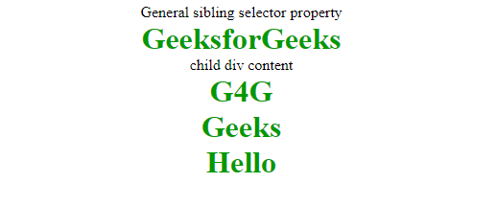

**Adjacent Sibling selector:** The Adjacent sibling selector is used to select the element that is adjacent or the element that is next to the specified selector tag. This combinator selects only one tag that is just next to the specified tag. **div** + **p**{

**color**: #009900;

**font-size**:32px;

**font-weight**:**bold**;

**margin**:0px;

**text-align**:**center**;

}

# combinators property

**Child Selector:** This selector is used to select the element that is the immediate child of the specified tag. This combinator is stricter than the descendant selector because it selects only the second selector if it has the first selector element as its parent.

**div** > **p**{

**color**: #009900;

**font-size**:32px;

**font-weight**:**bold**;

**margin**:0px;

**text-align**:**center**;

}

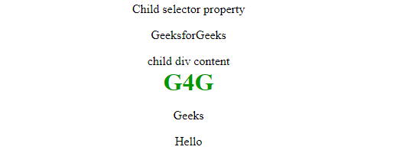

**Descendant selector:** This selector is used to select all the child elements of the specified tag. The tags can be the direct child of the specified tag or can be very deep in the specified tag.

**div** **p**{

**color**: #009900;

**font-size**:32px;

**font-weight**:**bold**;

**margin**:0px;

**text-align**:**center**;

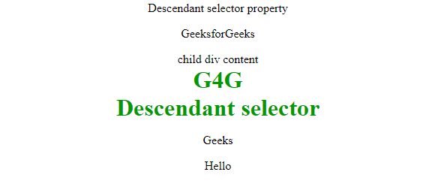 }

# CSS Pseudo-classes

CSS Pseudo-classes are powerful and allow developers to style elements based on their specific states.

**Note**that pseudo-class names are not case-sensitive.

# pseudo elements:

selected with ::

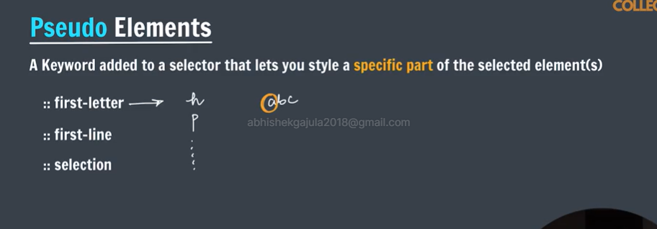

# Cascading in css.

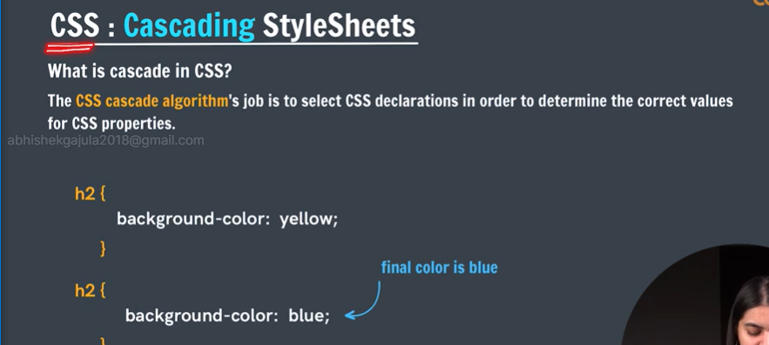

* + The algorithm even in case of the files.

# Specificity:

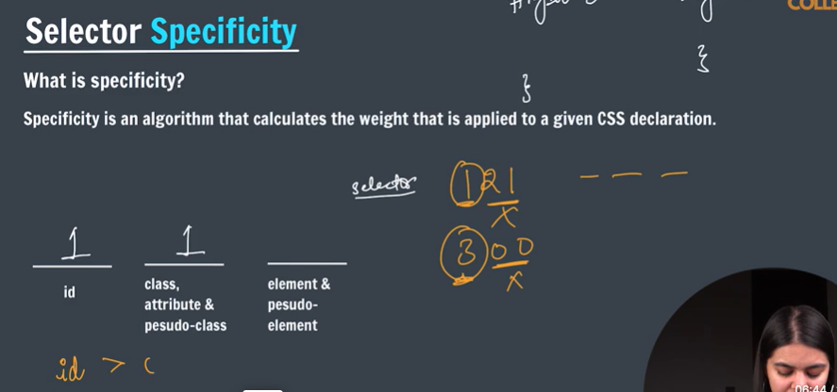

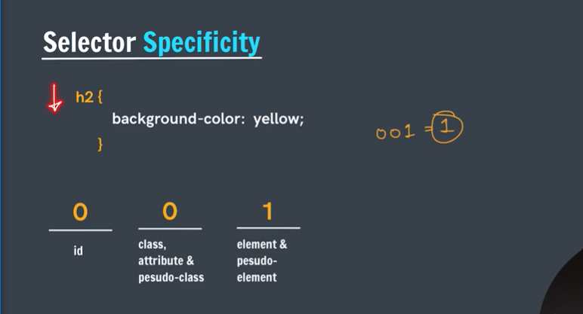

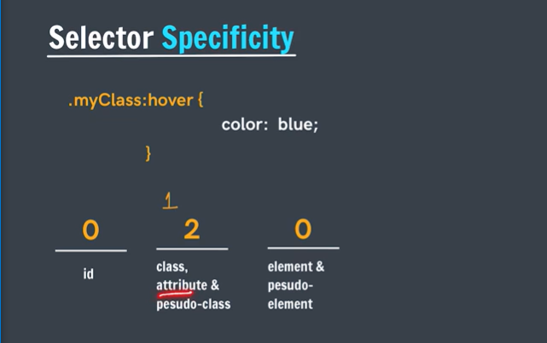

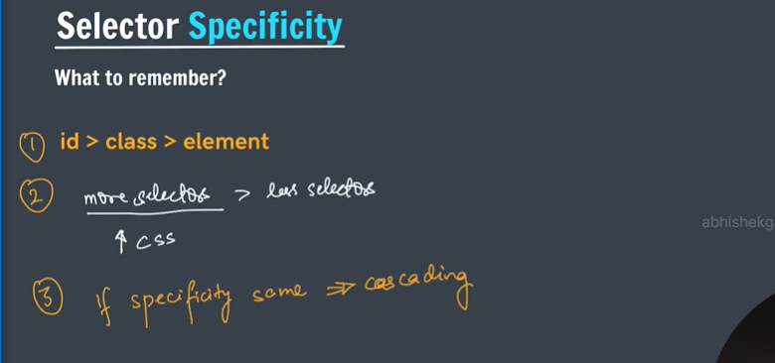

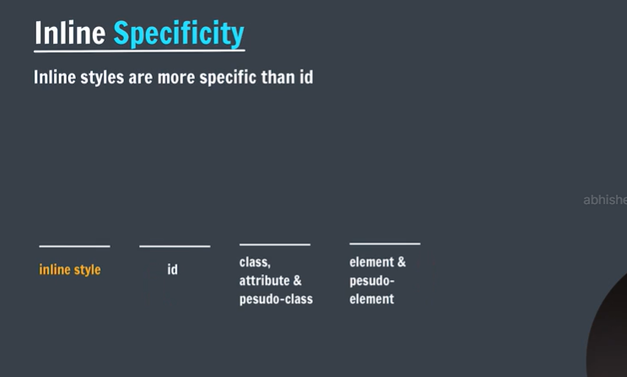

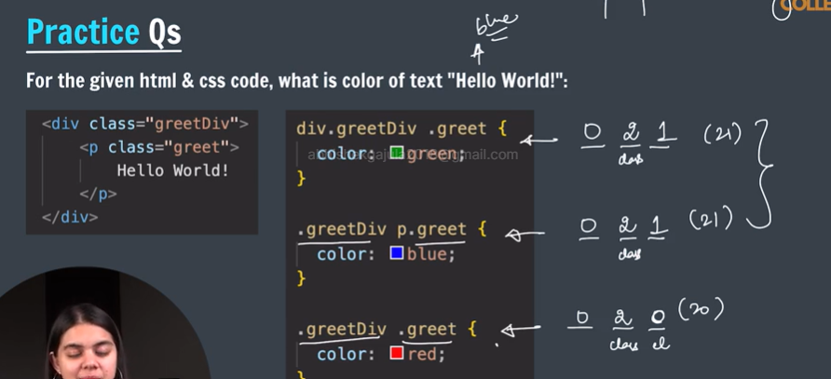

# **CSS The !important Rule**

The !important rule in CSS is used to add more importance to a property/value than normal.

In fact, if you use the !important rule, it will override ALL previous styling rules for that specific property on that element!

p {  
  background-color: red **!important**;  
}

# Inheritance in css:

* [**CSS Inheritance**](https://www.geeksforgeeks.org/how-to-apply-concept-of-inheritance-in-css/)**:** In CSS inheritance, the child element will naturally inherit properties from its parent element if and only if child has no css properties.
* Form elements doesn’t inheritance the properties of parent elements.
* To do that we to specify the child element background as “inherit”.
* NOTE: NOT ALL PROPERTIES WILL BE INHERITED
* EG: WIDTH,HEIGHT

# Box model in css:

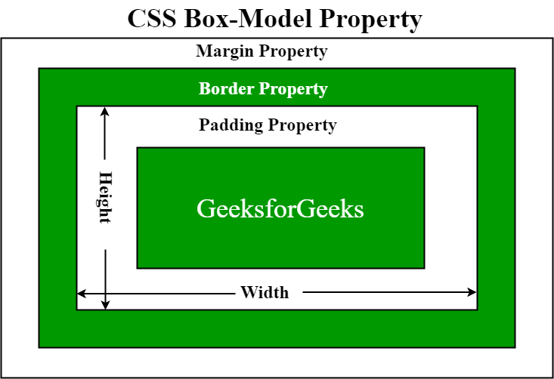

**CSS Box Model** is a Fundamental concept in [CSS](https://www.geeksforgeeks.org/css-tutorial/) that governs how elements are structured and positioned on a webpage.

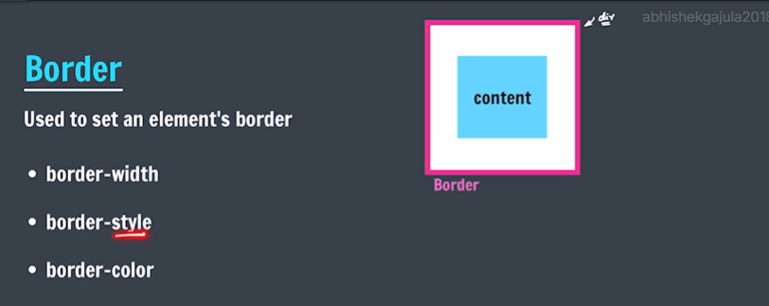

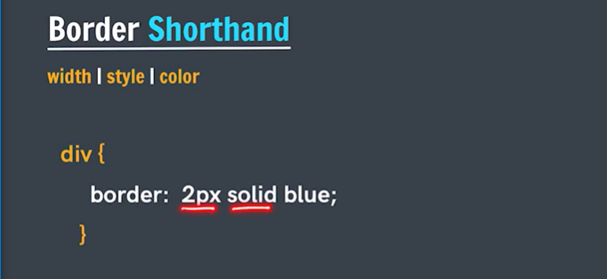

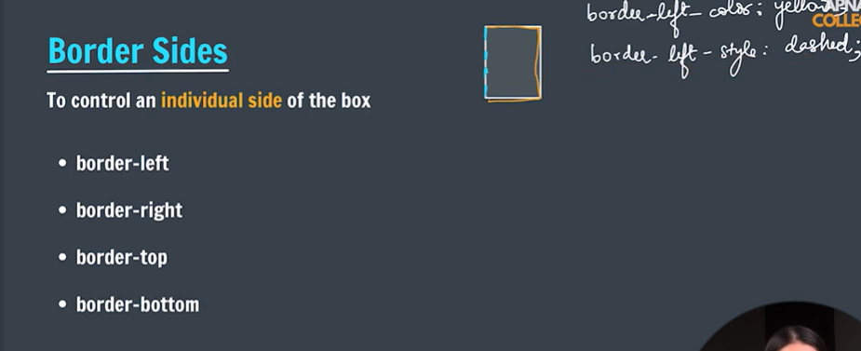

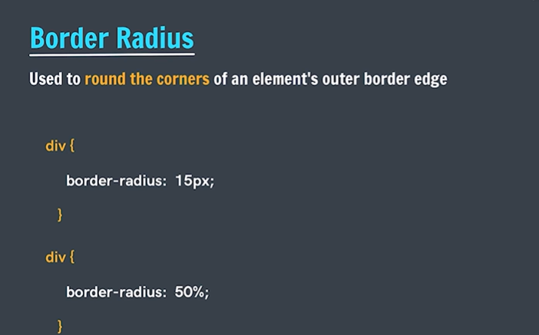

* We can control individual borders like:

Border-top-right-radius: 50px;

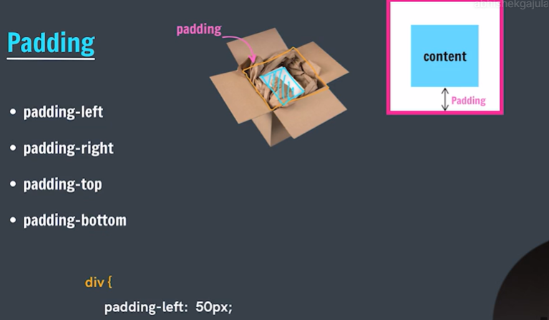

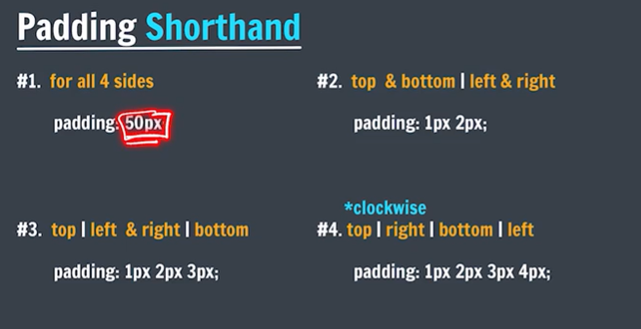

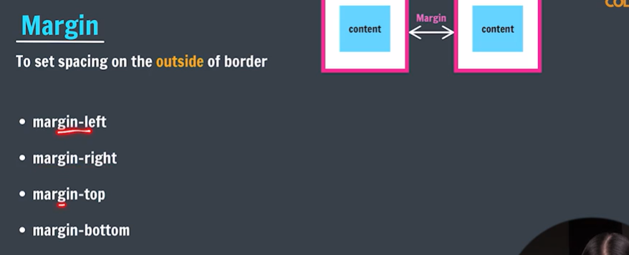

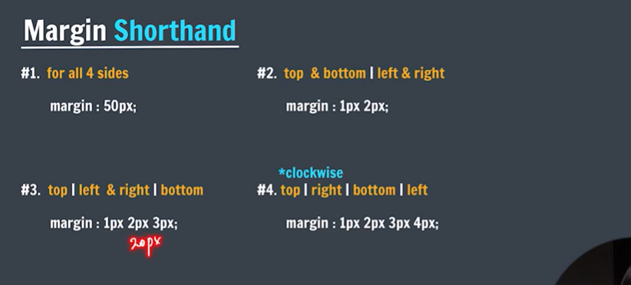

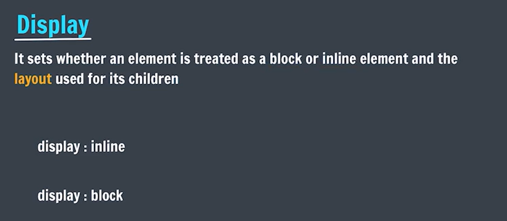

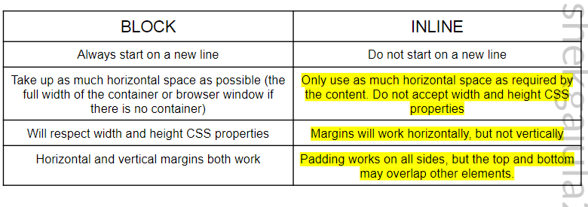

## inline-block Value

Compared to display: inline, the major difference is that display: inline-block allows to set a width and height on the element.

Also, with display: inline-block, the top and bottom margins/paddings are respected, but with display: inline they are not.

Compared to display: block, the major difference is that display: inline-block does not add a line-break after the element, so the element can sit next to other elements.

# Relative units in css:

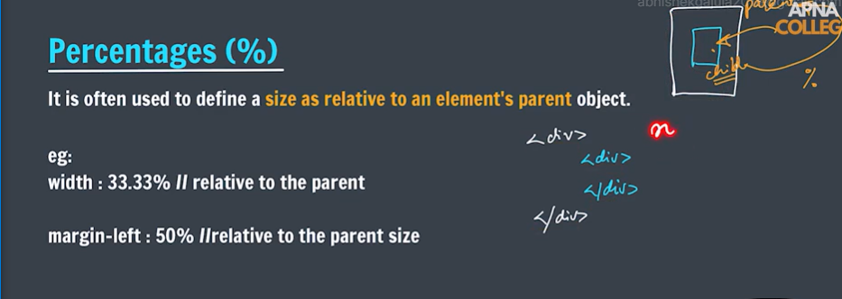

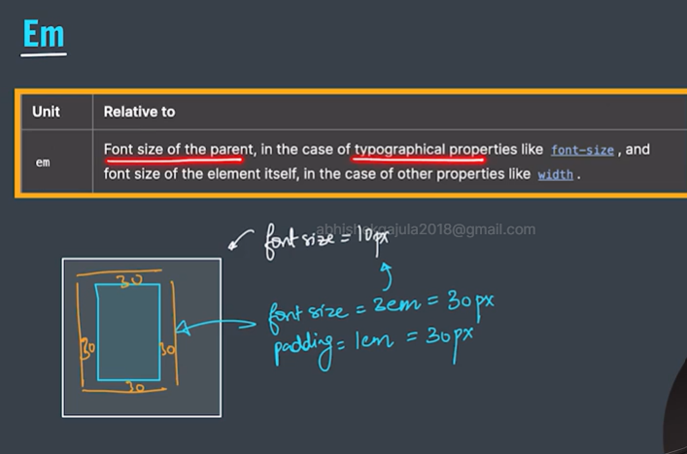

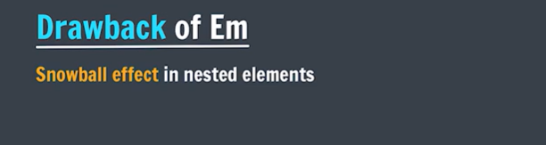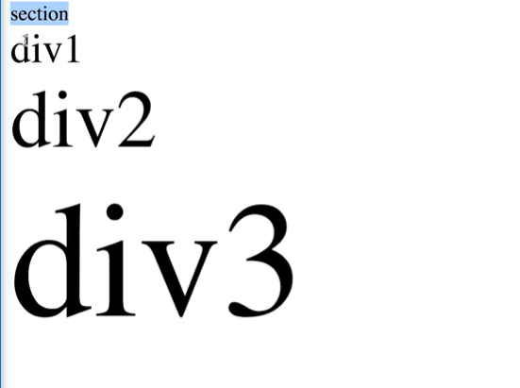

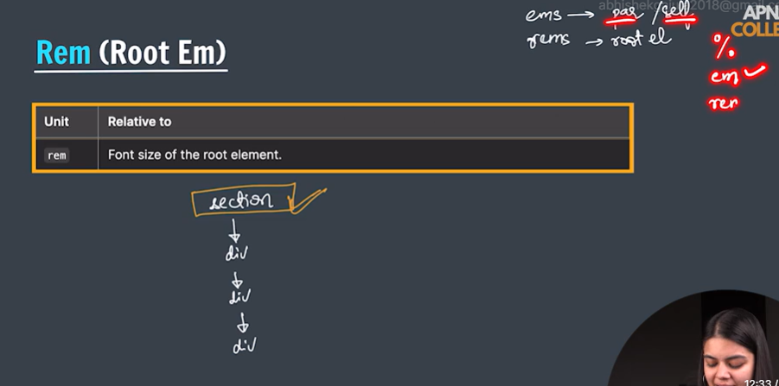

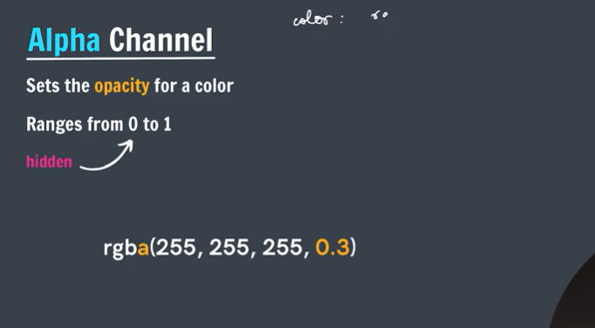

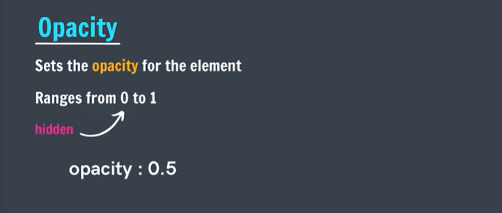>

# > CSS Transitions

Transitions in CSS allow us to control how the transition takes place between the two states of the element. For example, when hovering your mouse over a button, you can change the background color of the element with the help of a CSS selector and [pseudo-class](https://www.geeksforgeeks.org/css-pseudo-classes/).

**All these properties must be placed along with other CSS properties of the initial state of the element:**

**1. transition-property:** This property allows you to select the CSS properties that you want to animate during the transition(change).

**Syntax:**

transition-property: none | all | property | property1,  
property2, ..., propertyN;

* **Values**:
  + **none** is used to specify that no property should be selected.
  + **all** is used to specify all the properties to be selected, though not all properties are animate-able, only the properties which are animate-able will be influenced.
  + We can specify a single **property** or a set of comma-separated properties **property1, property2, …, propertyN**.

**2. transition-duration:** This property allows you to determine how long it will take to complete the transition from one CSS property to the other.

**Syntax:**

transition-duration: time;

* Here, **time** can be in seconds(s) or milliseconds(ms), you should use ‘s’ or ‘ms’ after the number (without quotes).

**3. transition-timing-function:** This property allows you to determine the speed of change and the manner of change, during the transition. Like, the change should be fast at the beginning and slow at the end, etc.

**Syntax:**

transition-timing-function: ease|ease-in|ease-out|ease-in-out|linear|  
step-start|step-end;

* Note, there are other values that this transition-timing-function can take, only the most frequent and simple are mentioned here.

**4. transition-delay:** This property allows you to determine the amount of time to wait before the transition actually starts to take place.

**Syntax:**

transition-delay: time;

* Here, again, **time** can be in seconds(s) or milliseconds(ms), and you should use ‘s’ or ‘ms’ after the number (without quotes).

**The Shorthand Property** You can combine all the four transition properties mentioned above, into one single shorthand property, according to the syntax given below. This saves us from writing long codes and prevents from getting messy. Note the ordering of property, it has significance.

**Syntax:**

transition: (property name) | (duration) | (timing function) | (delay);

**h1** {

**color**: **green**;

**text-align**: **center**;

}

**div**.**one** {

**height**: 150px;

**width**: 150px;

**border**: 1px **dashed** **black**;

**margin**: 0 **auto**;

**background**: #FFEBEE;

**transition**: **height** 2s, **width** 2s, **background** 2s;

}

**div**.**one**:hover {

**height**: 300px;

**width**: 300px;

**background**: #BBDEFB;

}

# Transforms in css:

The **transform property** in CSS is used to change the coordinate space of the visual formatting model. This is used to add effects like skew, rotate, translate, etc on elements.

**Values:**

* **none**: No transformation takes place.
* **matrix(x, x, x, x, x, x):** It specifies a matrix transformation of 2-D type. It takes 6 values.
* **matrix3d(x, x, x, x, x, x, x, x, x):** It specifies a matrix transformation of 3-D type. It takes 9 values.
* **translate(x, y):** It specifies a translation across the X and Y axes.
* **translate3d(x, y, z):** It specifies a translation across the X, Y, and Z axes.
* **translateX(x):** It specifies the translation across the X-axis only.
* **translateY(y):** It specifies the translation across the Y-axis only.
* **translateZ(z):** It specifies the translation across the Z-axis only.
* **rotate(angle):** It specifies the angle of rotation.

**Eg:**

Div{

Transform:rotate(120deg);

* **rotateX(angle):** It specifies the rotation along with the X-axis corresponding to the angle of rotation.
* **rotateY(angle):** It specifies the rotation along with the Y-axis corresponding to the angle of rotation.
* **rotateZ(angle):** It specifies the rotation along with the Z-axis corresponding to the angle of rotation.
* **scale(x, y):** It specifies the scale transformation along the X and Y axes.
* **scaleX(x):** It specifies the scale transformation along the X-axis.
* **scaleY(y):** It specifies the scale transformation along the Y-axis.
* **scaleZ(z):** It specifies the scale transformation along the Z-axis.
* **scale3d(x, y, z):** It specifies the scale transformation along the X, Y, and Z axes.
* **skew(angle, angle):** It specifies the skew transformation along the X and Y axes corresponding to the skew angles.
* **skewX(angle)**: It specifies the skew transformation along with the X-axis corresponding to the skew angle.
* **skewY(angle)**: It specifies the skew transformation along with the Y-axis corresponding to the skew angle.
* **skewZ(angle)**: It specifies the skew transformation along with the Z-axis corresponding to the skew angle.
* **perspective(x)**: It specifies the perspective of an element. Refer: [Perspective property](https://www.geeksforgeeks.org/css-perspective-property/)
* **initial**: It initializes the element to its default value.
* **inherit**: It inherits the value from its parent element.
* **Note**: the above properties is also applicable to inner elements also.

div.a {  
  transform: rotate(20deg);  
}  
  
div.b {  
  transform: skewY(20deg);  
}  
  
div.c {  
  transform: scaleY(1.5);  
}

# Box shadow:

The **box-shadow** [CSS](https://developer.mozilla.org/en-US/docs/Web/CSS) property adds shadow effects around an element's frame. You can set multiple effects separated by commas. A box shadow is described by X and Y offsets relative to the element, blur and spread radius, and color.

/* Three length values and a color */

/* <length> | <length> | <length> | <color> */

box-shadow: 10px 5px 5px black;

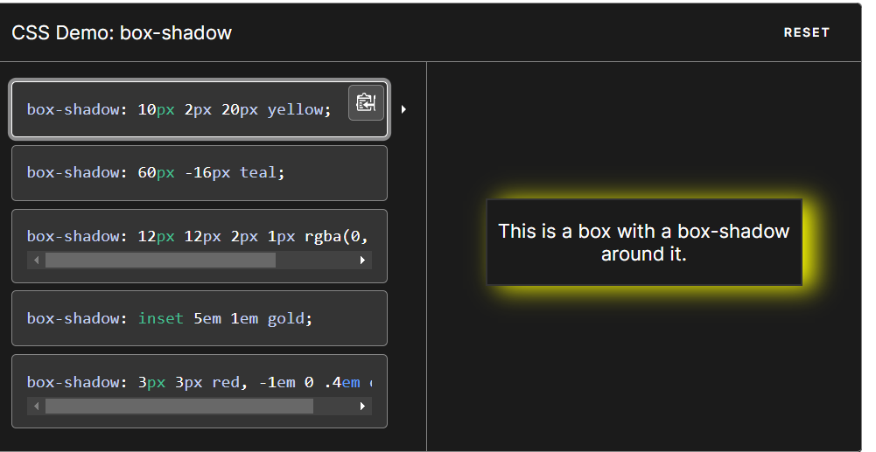

# Background image:

The **background-image** Property is used to set one or more background images for an element. By default, it places the image in the top left corner. To specify two or more images, we need to specify the separate URLs with a comma for both images.

background-image: url('url')|none|initial|inherit;

**Property Values**

| **Values** | **Description** |
| --- | --- |
| **url(‘url’)** | This specifies the URL of the image. To specify the URL of more than one image then separate the URLs using a comma. |
| nope | This is the default case where no image can be displayed. |
| initial | It is used to set the property to its default value. |
| inherit | It inherits the property from its parent element. |

Note:for copyright free images visit splash website .

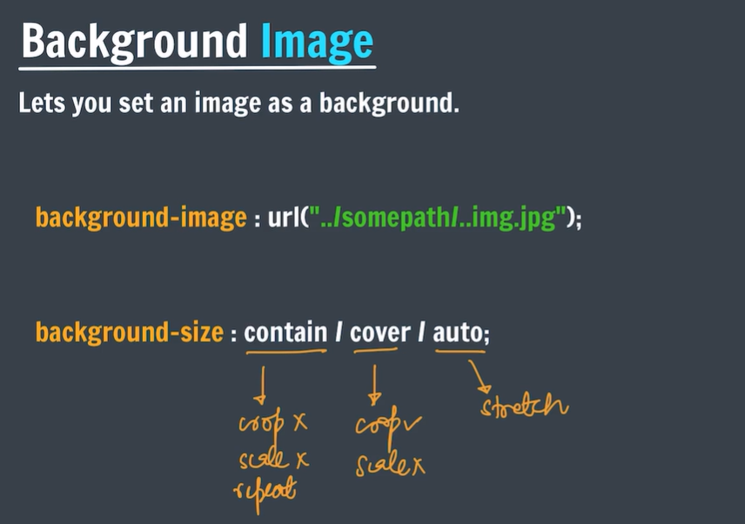

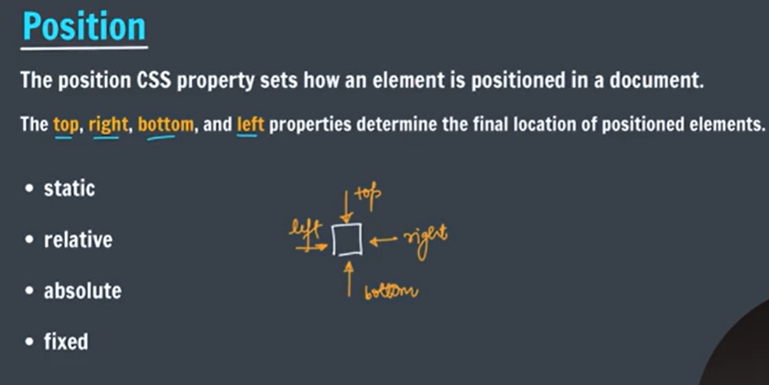

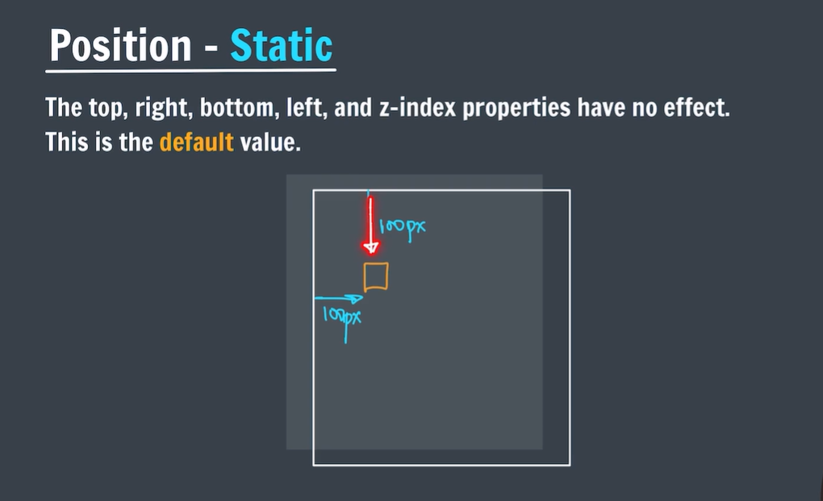

Offset



* + In static positioning the element will have static(where html will allocate its default position) position irrespective to there positioning attributes.

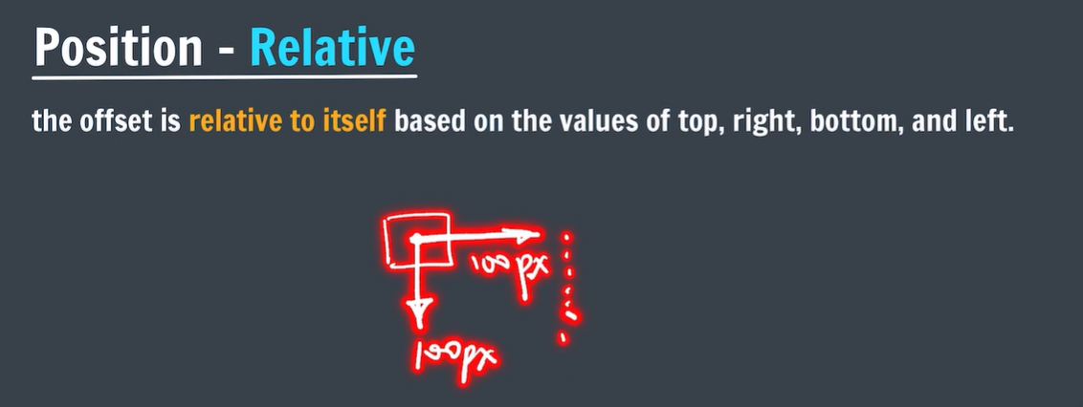

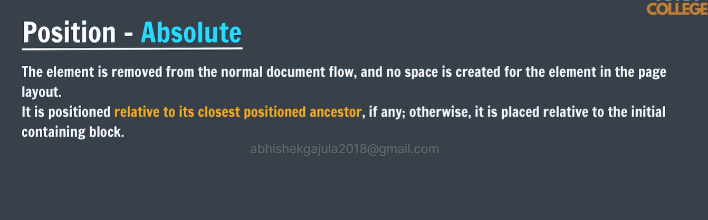

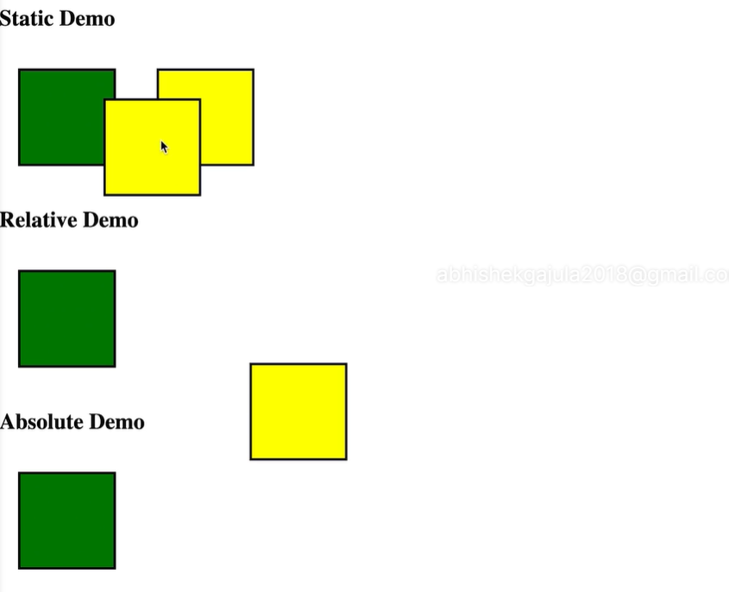

* + In absolute demo the box adjusted with grand parent (body) (not direct parent -section). \

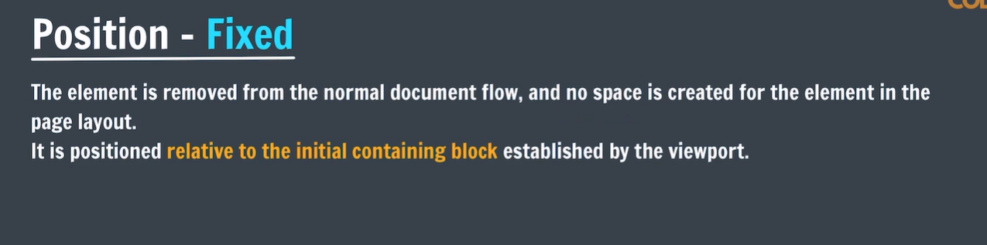

* + An element with position: fixed property remains in the same position relative to the viewport even when the page is scrolled.

>

|  |  |
| --- | --- |
| Sticky | Combines features of position: relative and position: fixed. The element is treated as position: relative until it reaches a specified threshold, then it becomes position: fixed. |

# Flexbox in css:

CSS Flexbox, short for Flexible Box Layout, offers a streamlined way to design adaptable and visually appealing layouts. It works primarily in one dimension (row or column) to intelligently distribute space among elements within a container.

This results in clean alignment and responsive designs that work seamlessly across different screen sizes – perfect for crafting both smaller components and overall webpage structure.

**Features of flexbox:**

* A lot of flexibility is given.
* Arrangement & alignment of items.
* Proper spacing
* Order & Sequencing of items.
* Bootstrap 4 is built on top of the flex layout.

**Before the Flexbox Model:**

* **Block:** It is used to make sections in web pages.
* **Inline:** It is used for text.
* **Table:** It is used for two-dimensional table data.
* **Positioned:** It is used for the explicit position of an element.

### There are 2 main components of the Flexbox:

* **Flex Container**: The parent “div” which contains various divisions is called a flex container.
* **Flex Items**: The items inside the container “div” are flex items.

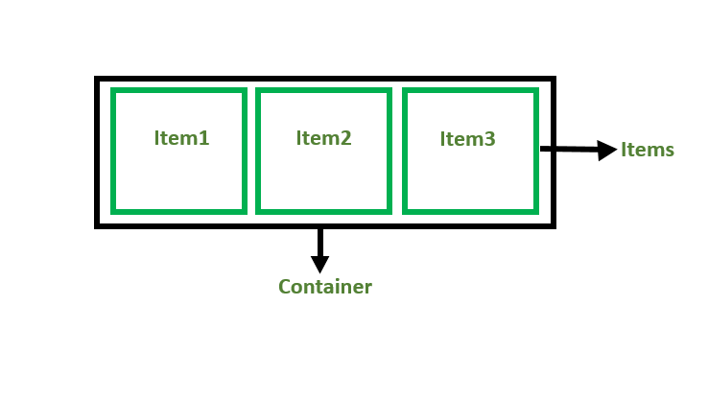

For creating the flexbox, we need to create a flex container along with setting the display property to flex.

**Flexbox Axes:** While working with Flexbox, we deal with 2 axes:

* Main Axis
* Cross Axis

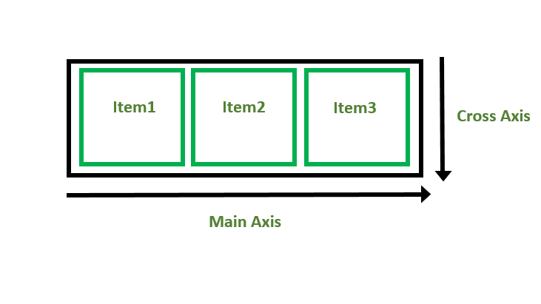

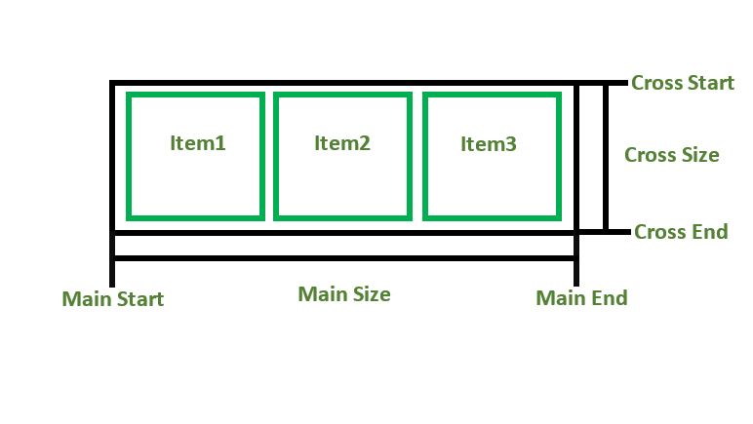

* Items can grow or shrink to fill the available space or to prevent overflow.
* Available space is distributed among other items.

**Axes of flexbox:**

* The main axis:

              A) left to right

flex-direction: row

              B) right to left

flex-direction: row-reverse

              C) top to bottom

flex-direction: column

              D) bottom to top

flex-direction: column

* The cross axis (perpendicular to main axis)

**Properties of flexbox:**

Parent properties:

* **display** defines a flex container – flex formatting context.
* **flex-direction** defines the main axis inside the container.
* **flex-wrap** allows flex items to wrap onto more than one line.
* 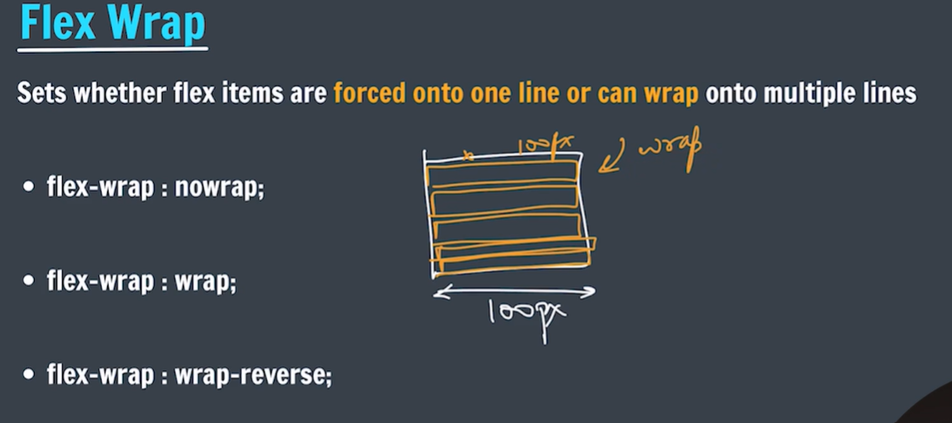

Wrap-reverse:wrap the elements over the cross axis.

* **flex-flow** shorthand for *flex-direction + flex-wrap*.
* **justify-content** allows items to align along main axis.  
  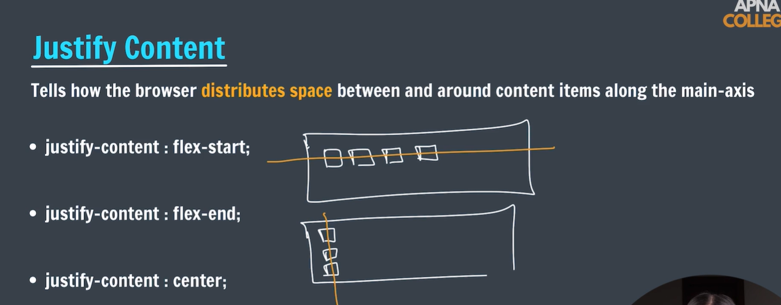
* 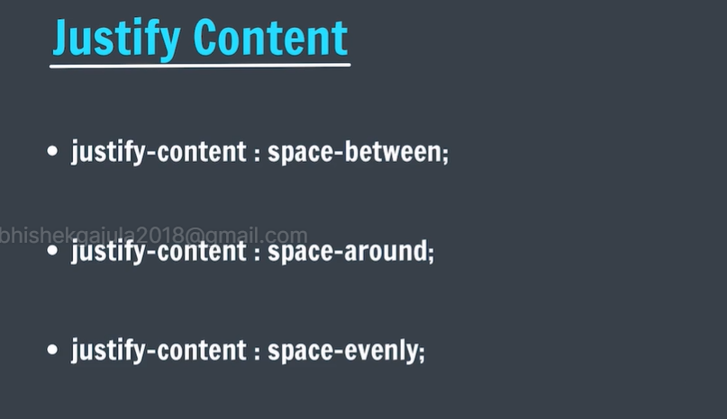
* **Space-between** : will distribute the remaining space in between the elements.
* **Space-around**:also distribute to the first half to the left side of the first element and second half to the right side of the last element.
* **Space-evenly**: constant space for all the elements including first and last element.
* **Baseline**:align the elements according to the content in the individual items.
* **flex-start:will align the elemets from the stating point of main axis.**
* **Flex-end:will align the elements from the ending point of main axis.**
* **Flex-center:will align the elements exactly between the centre of the main axis.**
* **align-content** allows items to align along cross axis in a single line.
* 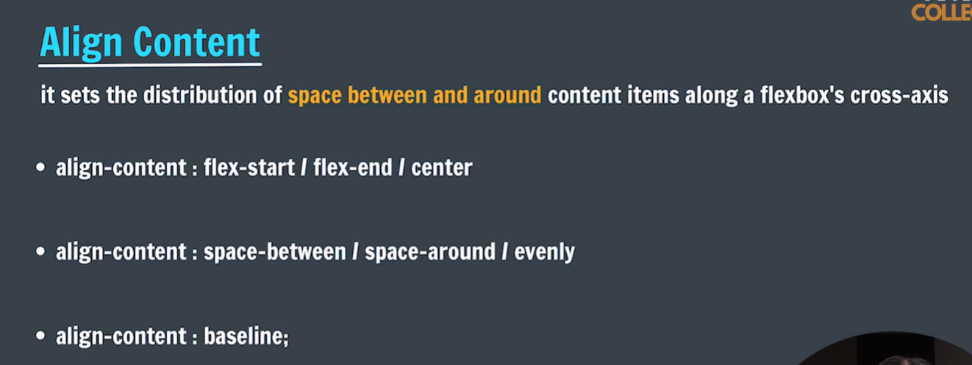
* **align-items** aligns multiple lines of items on the cross axis.

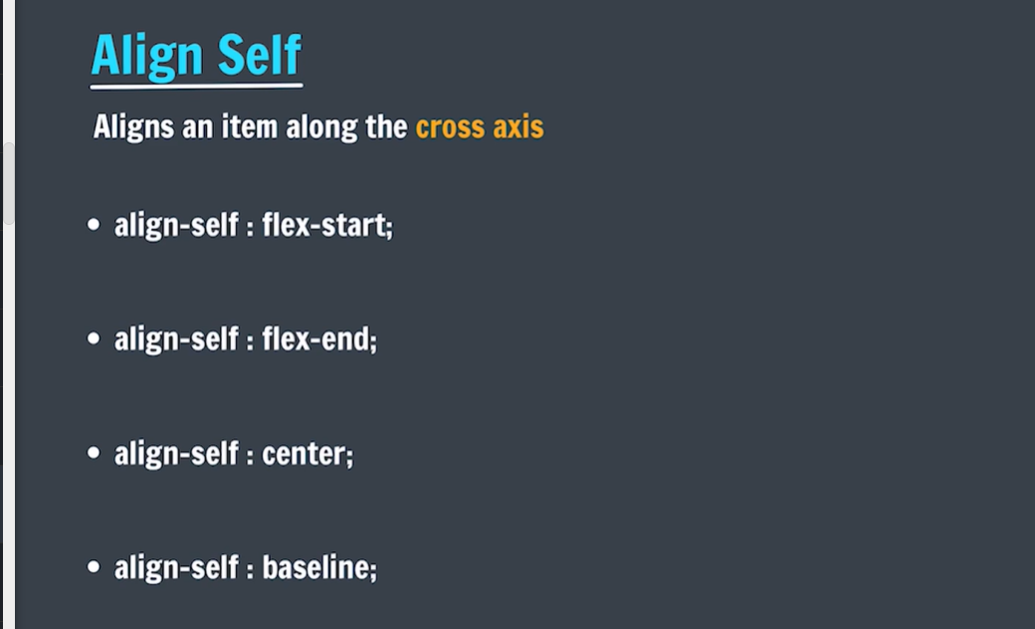**Same as justify content but it works over the cross axis.**

* + **Align self-is assigned to individual items.**

## Align self has higher priority than align items. [Properties that control alignment](https://developer.mozilla.org/en-US/docs/Web/CSS/CSS_flexible_box_layout/Aligning_items_in_a_flex_container#properties_that_control_alignment)

The properties we will look at in this guide are as follows.

* [justify-content](https://developer.mozilla.org/en-US/docs/Web/CSS/justify-content) — controls alignment of all items on the main axis.
* [align-items](https://developer.mozilla.org/en-US/docs/Web/CSS/align-items) — controls alignment of all items on the cross axis.
* [align-self](https://developer.mozilla.org/en-US/docs/Web/CSS/align-self) — controls alignment of an individual flex item on the cross axis.
* [align-content](https://developer.mozilla.org/en-US/docs/Web/CSS/align-content) — described in the spec as for "packing flex lines"; controls space between flex lines on the cross axis.
* [gap](https://developer.mozilla.org/en-US/docs/Web/CSS/gap), [column-gap](https://developer.mozilla.org/en-US/docs/Web/CSS/column-gap), and [row-gap](https://developer.mozilla.org/en-US/docs/Web/CSS/row-gap) — used to create gaps or gutters between flex items.

We will also discover how auto margins can be used for alignment in flexbox.

# Flex sizing:

1. Flex-basis: The **flex-basis** [CSS](https://developer.mozilla.org/en-US/docs/Web/CSS) property sets the initial main size of a flex item. It sets the size of the content box unless otherwise set with [box-sizing](https://developer.mozilla.org/en-US/docs/Web/CSS/box-sizing).

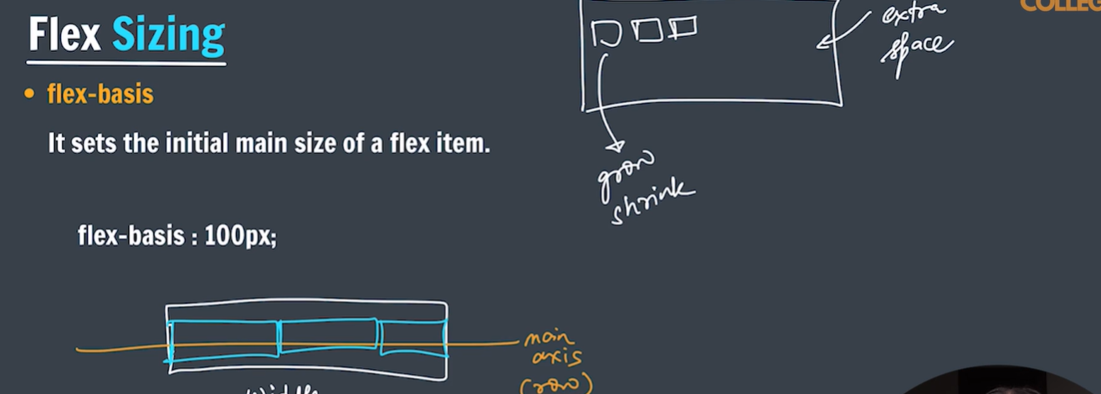

Flex basis size is applied according to the main axis and flex basis is used for individual objects.

1. **Flex-grow:** it increase size of the element along the main axis if there is fee space.

The units of flex-grow is numbers which indicates the proportions to be increased.

We can restrict the growing and shrinking size of an element by using min-width and max-width.

div:nth-of-type(1) {flex-grow: 1;}  
div:nth-of-type(2) {flex-grow: 3;}  
div:nth-of-type(3) {flex-grow: 1;}

1. **Flex-shrink:** it decreases the size of the element along the main axis if there is no free space available.

The units of flex-shrink is numbers which indicates the proportions to be increased.

When overflow occurs the size will shrink of the given element.

/* <number> values */

flex-shrink: 2;

flex-shrink: 0.6;

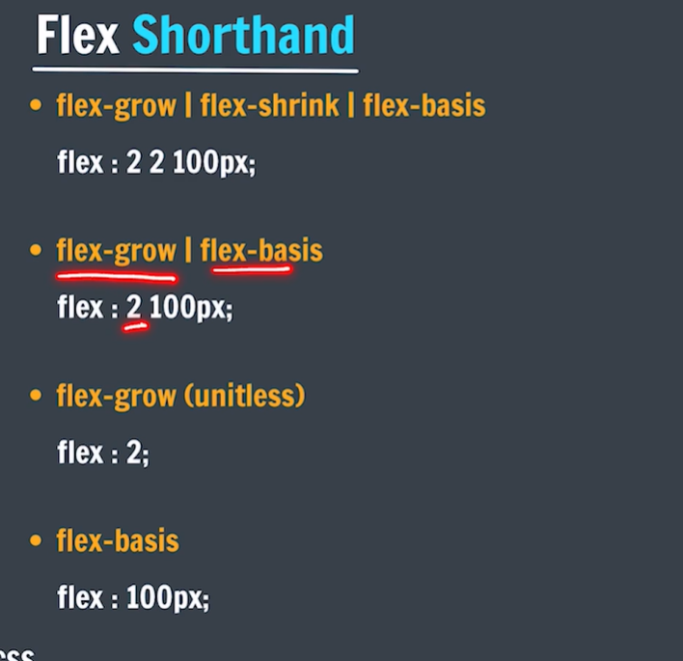

# Grid in css:

The **CSS Grid Layout Module**is a revolutionary tool in the realm of web development. It introduces a **grid-based layout system**, facilitated by rows and columns, that simplifies the design process of any webpage. This system eliminates the need for floats and positioning, making it a game-changer for developers.

**CSS Grid Layout Module** creates a grid-based layout system, with the help of rows and columns, and makes it easier to design any webpage without using **floats** and **positioning**.

.class {  
 display:grid;  
}

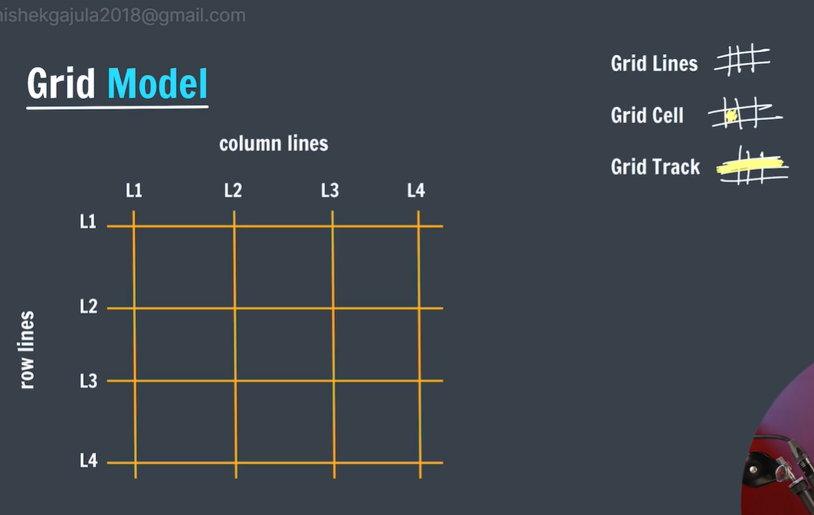

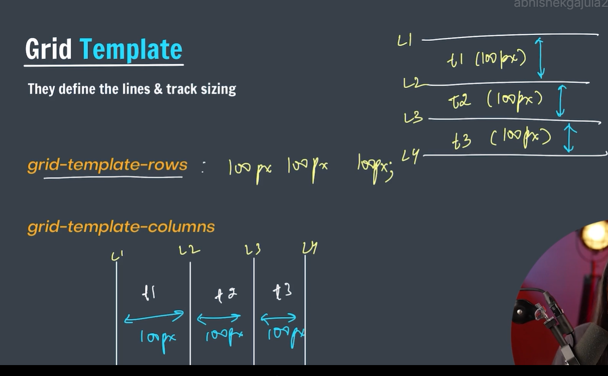

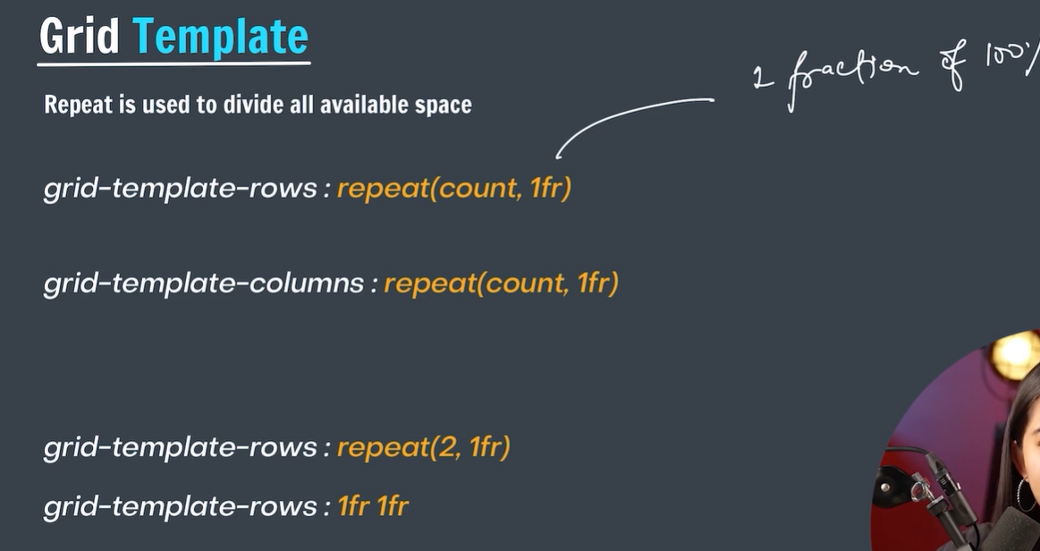

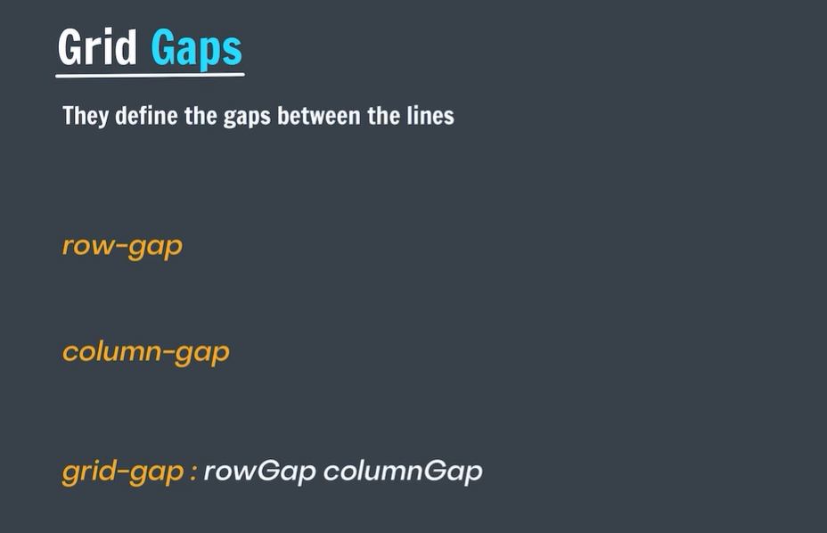

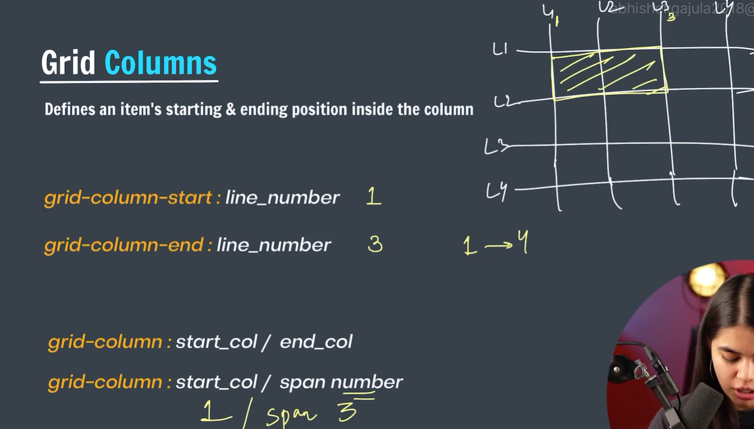

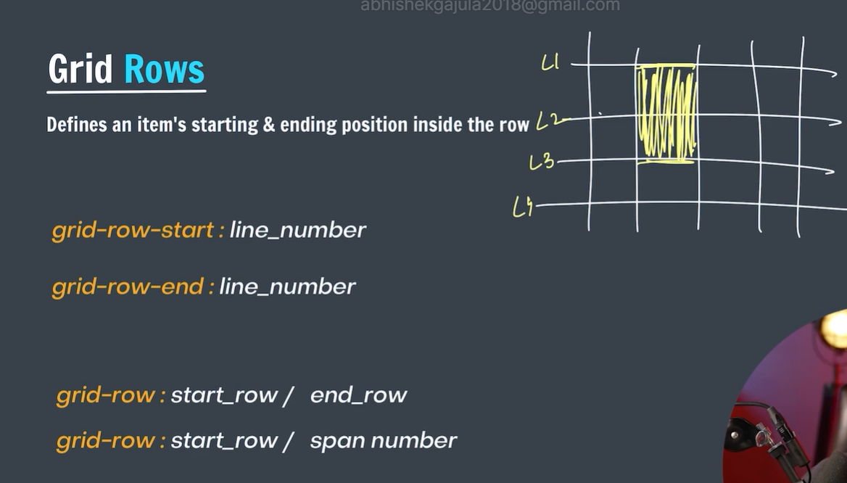

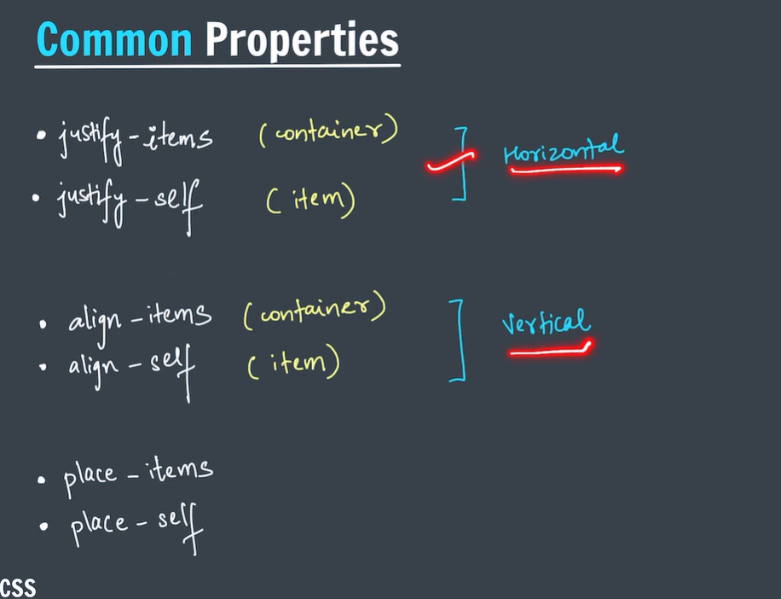

NOTE: TO MAKE GRID AND FLEX CONTAINER TO INLINE WE HAVE TO SPECIFY THAT

Display:inline-grid;

Display:inline-flex;

| **Property** | **Description** |
| --- | --- |
| [**column-gap**](https://www.geeksforgeeks.org/css-column-gap-property/) | It is used to specify the amount of gap between the columns in which a given text is divided using the column-count property. |
| [**gap**](https://www.geeksforgeeks.org/css-gap-property/) | It is used to set the spacing also caller gutter between the rows and columns. |
| [**grid**](https://www.geeksforgeeks.org/css-grid-property/) | It offers a grid-based layout system, with rows and columns, making it easier to design web pages without floats and positioning. |
| [**grid-area**](https://www.geeksforgeeks.org/css-grid-area-property/) | It is used to set a grid item size and location in a grid layout. |
| [**grid-auto-columns**](https://www.geeksforgeeks.org/css-grid-auto-columns-property/) | It is used to specify the size for the columns of implicitly generated grid containers. |
| [**grid-auto-flow**](https://www.geeksforgeeks.org/css-grid-auto-flow-property/) | It specifies exactly how auto-placed items get flow into the grid. |
| [**grid-auto-rows**](https://www.geeksforgeeks.org/css-grid-auto-rows-property/) | It is used to specify the size for the rows of implicitly generated grid containers. |
| [**grid-column**](https://www.geeksforgeeks.org/css-grid-column-property/) | It describes the number of properties that allow to design of grid structures and control the placement of grid items using CSS. |
| [**grid-column-end**](https://www.geeksforgeeks.org/css-grid-column-end-property/) | It explains the number of columns an item will span, or on which column-line the item will end. |
| [**grid-column-gap**](https://www.geeksforgeeks.org/css-grid-column-gap-property/) | It is used to set the size of the gap between the columns in a grid layout. |
| [**grid-column-start**](https://www.geeksforgeeks.org/css-grid-column-start-property/) | It defines for which column line item will start. |
| [**grid-gap**](https://www.geeksforgeeks.org/css-grid-gap-property/) | It is used to sets the size of the gap between the rows and columns in a grid layout. |
| [**grid-row**](https://www.geeksforgeeks.org/css-grid-row-property/) | It is used to specify the size and location in a grid layout. |
| [**grid-row-end**](https://www.geeksforgeeks.org/css-grid-row-end-property/) | It is used to define the grid item’s end position within a grid row by specifying the inline edge of its grid area. |
| [**grid-row-gap**](https://www.geeksforgeeks.org/css-grid-row-gap-property/) | It is used to define the size of the gap between the grid elements. |
| [**grid-row-start**](https://www.geeksforgeeks.org/css-grid-row-start-property/) | It is used to define the grid items’ start position within the grid row by specifying the inline start edge of its grid area. |
| [**grid-template**](https://www.geeksforgeeks.org/css-grid-template-property/) | It is a [shorthand property](https://www.geeksforgeeks.org/css-shorthand-properties/) for defining grid columns, rows, and areas. |
| [**grid-template-areas**](https://www.geeksforgeeks.org/css-grid-template-areas-property/https:/www.geeksforgeeks.org/css-grid-template-areas-property/) | It is used to specify the area within the grid layout. |
| [**grid-template-columns**](https://www.geeksforgeeks.org/css-grid-template-columns-property/) | It is used to set the number of columns and size of the columns of the grid. |
| [**grid-template-rows**](https://www.geeksforgeeks.org/css-grid-template-rows-property/) | It is used to set the number of rows and height of the rows in a grid. |

<!DOCTYPE html>

<html>

<head>

<style>

/* Designing all grid */

.grid-container {

display: grid;

grid-template-columns: auto auto auto;

background-color: gray;

padding: 5px;

}

/* Designing all grid-items */

.grid-item {

background-color: rgba(255, 255, 255, 0.8);

border: 1px solid black;

padding: 20px;

font-size: 30px;

text-align: center;

}

/* Designing h1 element */

h1 {

color: green;

text-align: center;

}

</style>

</head>

<body>

<h1>GeeksforGeeks</h1>

<!-- Creating grid -->

<div class="grid-container">

<div class="grid-item">1</div>

<div class="grid-item">2</div>

<div class="grid-item">3</div>

<div class="grid-item">4</div>

<div class="grid-item">5</div>

<div class="grid-item">6</div>

<div class="grid-item">7</div>

<div class="grid-item">8</div>

<div class="grid-item">9</div>

</div>

</body>

</html>

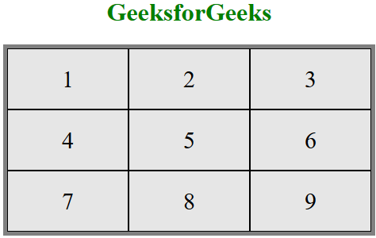

# CSS animations:

CSS Animations are a powerful tool that allows you to control the motion and display of elements on your web pages. They consist of two parts: one that describes the animation of the elements, and another that contains keyframes indicating the animation properties of the element at specific time intervals.

CSS Animations change the appearance and behavior of various elements in web pages. They are defined using the**@keyframes rule**, which specifies the animation properties of the element and the specific time intervals at which those properties should change.

## What is a Keyframe ?

**@keyframes Rule** or **Keyframes** are the foundations with the help of which CSS Animations work. They define the display of the animation at the respective stages of its whole duration.

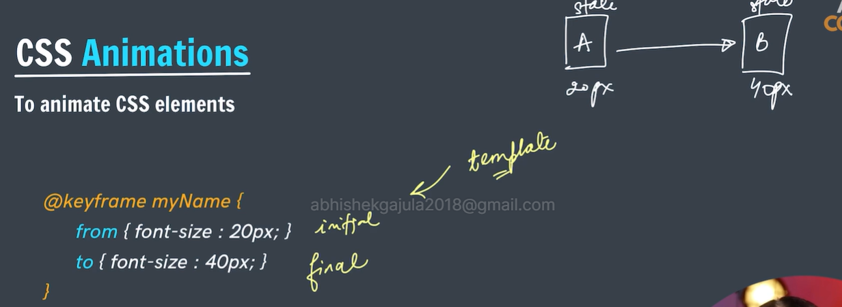

**<!DOCTYPE html>**

**<html>**

**<head>**

**<style>**

**#gfg {**

**animation-name: color;**

**animation-duration: 5s;**

**padding-top: 30px;**

**padding-bottom: 30px;**

**font-family: Times New Roman;**

**}**

**@keyframes color {**

**0% {**

**background-color: red;**

**}**

**50% {**

**background-color: orange;**

**}**

**100% {**

**background-color: brown;**

**}**

**}**

**</style>**

**</head>**

**<body>**

**<div id="gfg">**

**<h2>CSS Keyframes Animation</h2>**

**</div>**

**</body>**

**</html>**

| **Property** | **Description** |
| --- | --- |
| [**animation-name**](https://www.geeksforgeeks.org/css-animation-name-property/) | It is used to specify the name of the @keyframes describing the animation. |
| [**animation-duration**](https://www.geeksforgeeks.org/css-animation-duration-property/) | It is used to specify the time duration it takes animation to complete one cycle. |
| [**animation-timing-function**](https://www.geeksforgeeks.org/css-animation-timing-function-property/) | It specifies how animations make transitions through keyframes. There are several presets available in CSS which are used as the value for the animation-timing-function like **linear**, **ease,ease-in**,**ease-out**, and **ease-in-out.** |
| [**animation-delay**](https://www.geeksforgeeks.org/css-animation-delay-property/) | It specifies the delay of the start of an animation. |
| [**animation-iteration-count**](https://www.geeksforgeeks.org/css-animation-iteration-count-property/) | This specifies the number of times the animation will be repeated. |
| [**animation-direction**](https://www.geeksforgeeks.org/css-animation-direction-property/) | It defines the direction of the animation. animation direction can be **normal**, **reverse**, **alternate**, and **alternate-reverse**. |
| [**animation-fill-mode**](https://www.geeksforgeeks.org/css-animation-fill-mode-property/) | It defines how styles are applied before and after animation. The animation fill mode can be none, forwards, backwards, or both. |
| [**animation-play-state**](https://www.geeksforgeeks.org/css-animation-play-state-property/) | This property specifies whether the animation is running or paused. |

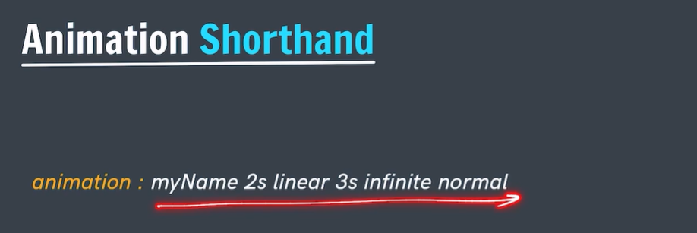

The @keyframes property has the option to divide the animation time into parts/percentage and perform an activity that is specified for that part of the whole duration of the animation.

 @keyframes circle {

            0% {

                background-color: red;

            }

            25% {

                background-color: yellow;

            }

            50% {

                background-color: blue;

            }

            100% {

                background-color: green;

            }

>